**Warp Store**

**Using your car store.**

Upon opening the store, you will see a list of cars. Each car will have the following information available:

* Model
* Manufacturer (Filterable)
* Body (Filterable)
* Price (Filterable)

On each car, there is an Add to Cart button. Clicking this button will add the car to your cart.  
*Please note: You will not be able to add a car to the cart more than once. The website will tell you that there is already one of the selected cars in the cart.*

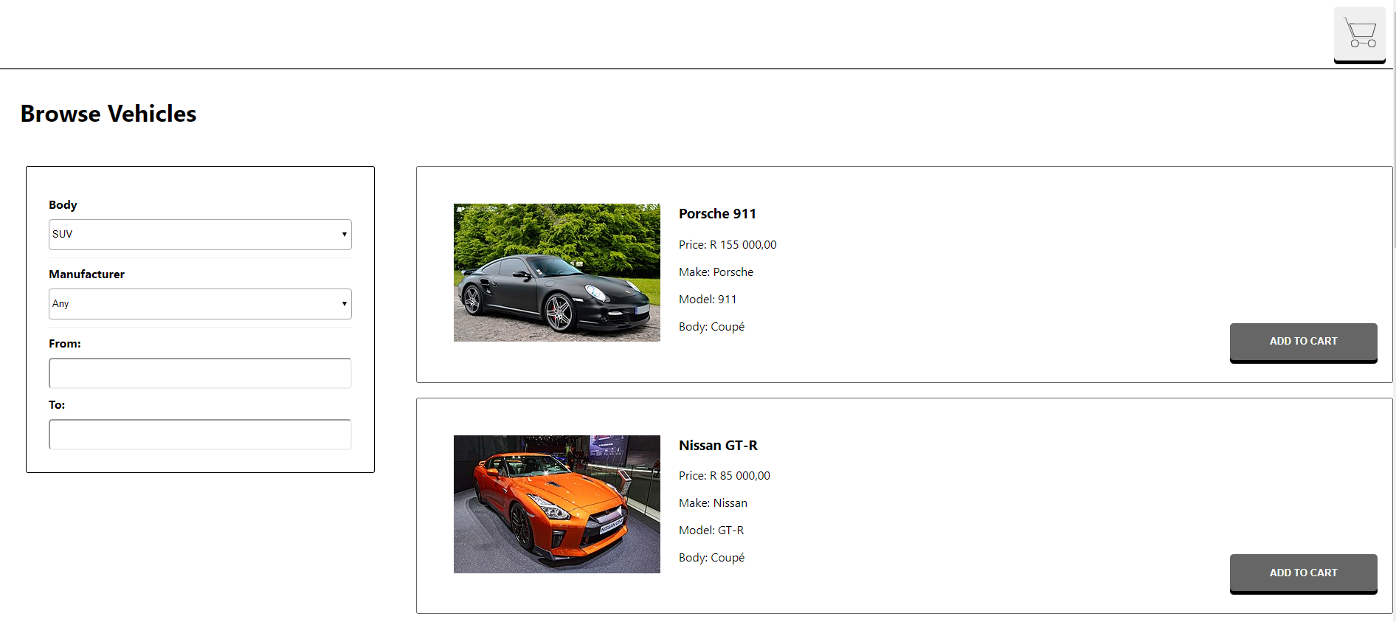

At the top-right hand corner, there is a cart button. Clicking on this will display items that are currently in your cart. Clicking the button again will hide the cart. If there is nothing in the cart, you will see the following message:

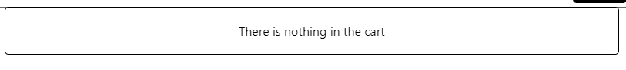

Adding a car to the cart will cause it to display as such:

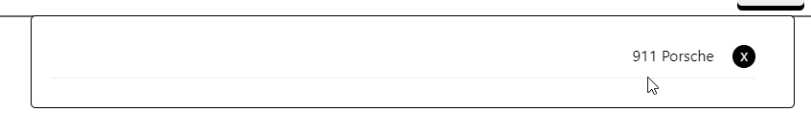

In order to remove a car from the cart, click on the button on the right of the cart item. This will remove the item from the cart, don’t worry, you will be able to add it again.

**Filters**

Use the filters on the left hand side to get to specific cars that you need.

Here you can filter according to the following information: Body (fig1), Manufacturer (fig2),   
and Price (fig 3).

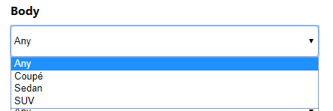

*Fig1*

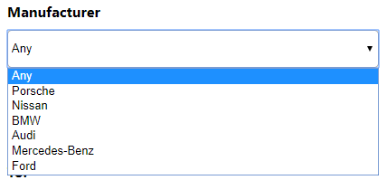

*Fig2*

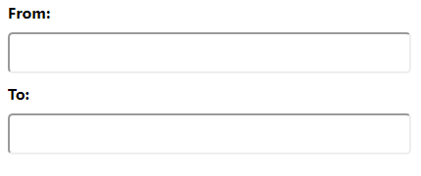

*Fig3*

Once the filter is selected, it will automatically apply. No need to press any additional buttons to apply the filter. If you don’t see what you are looking for, please change the filters back to the *any* option.

This concludes the guide on how to use your car store. Please feel free to contact us if you need any additional information.